Case 1-Eur-Bulgaria Stara Zagora-Figurine-Abstract-Ceramic-Neolithic-VI Millennium BCE

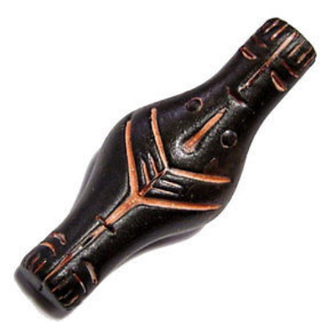

**Size: 92/37mm;                Weight: 28 g;**